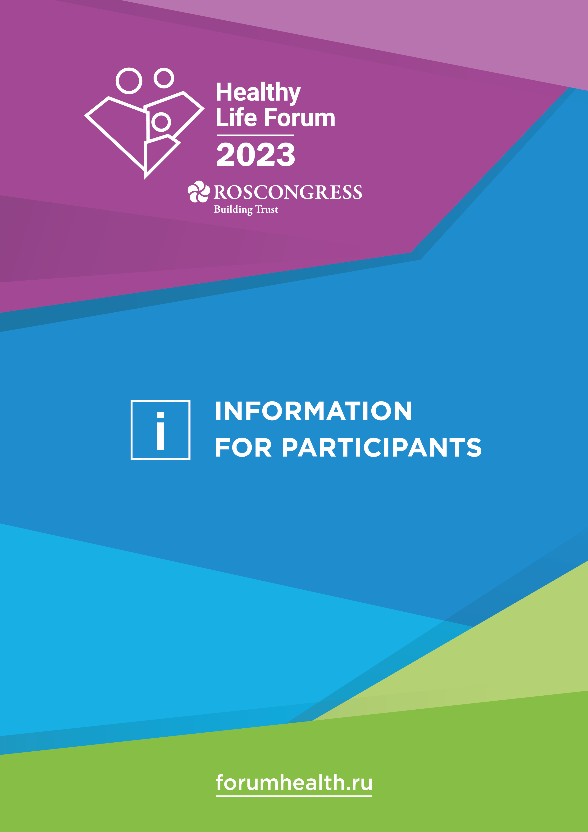

WELCOME
TO THE HEALTHY LIFE FORUM!
23–24 March 2023
Tauride Palace
(47, Shpalernaya Ulitsa, St. Petersburg)
Participants are kindly requested to arrive at the Forum venue 30–40 minutes before the start
of an event. The Forum venue may only be accessed with an accreditation badge.
There is no PCR test for COVID-19 or document confirming vaccination required to access the venue.
FORUM ORGANIZERS
- Roscongress Foundation’s Healthy Life project
- Russian Ministry of Health
with the support of
- Interparliamentary Assembly of Member Nations of the Commonwealth
of Independent States
- Government of the Leningrad Region
- Russian Ministry of Industry and Trade
CONTACT INFO
+7 (495) 777 1006
healthylife@roscongress.org
forumhealth.ru

CONTENTS
ARRIVAL IN ST. PETERSBURG 4
Visa regime 4
Arrival by air. Pulkovo airport 4
Arrival by rail 4
Weather in St. Petersburg 5
Currency and bank card transactions 5
Time zone 5
Electricity 5
FORUM VENUE 6
ACCESS TO THE FORUM VENUE 6
Accreditation badge 6
What should you check before collecting your badge? 6
How to find out if your badge is ready? 7
How to collect your badge? 7
Where to collect your badge? 8
PARTICIPATION FEE PAYMENT 8
BUSINESS PROGRAMME 8
SERVICES FOR PARTICIPANTS 9
Broadcasts of Forum events 9
Congress Attaché concierge service 9
Roscongress photo bank 9
Information and services point 9
Mobile device charging 9
Lost & found 10
Cloakroom 10
First aid 10
ROSCONGRESS.ORG INFORMATION AND ANALYTICAL SYSTEM 10
TRANSPORT 11
Forum shuttle buses 11
Vehicle rentals 12
DINING AT THE FORUM VENUE 12
Coffee break area (free of charge) 12
Café (payment required) 12
GENERAL INFORMATION 12
Emergency services 12
Emergency procedures 13

ARRIVAL IN ST. PETERSBURG

VISA REGIME
To enter the Russian Federation, you must have a valid passport, visa, and health insurance policy that is valid on the territory of the Russian Federation.
To obtain a visa, you must contact the appropriate consular office of the Russian Federation abroad. If the Russian Federation has an agreement about visa-free travel with your country, foreign citizens may enter the Russian Federation without visas.
The locations of your nearest Russian consular office can be found on the website of the Ministry of Foreign Affairs of the Russian Federation.
It is not required to take a PCR test before entering the Russian Federation or quarantine upon arrival.

ARRIVAL BY AIR. PULKOVO AIRPORT
Pulkovo Airport (LED) is St. Petersburg’s only airport that serves scheduled domestic and international flights. The journey from the airport to the Forum venue takes about 60 minutes (depending on the traffic).
41ZA, Pulkovskoye Shosse, St. Petersburg
+7 (812) 324 3000, +7 (812) 337 3822, +7 (812) 337 3444
pulkovoairport.ru
VIP service | +7 (812) 324 3446, +7 (921) 909 0440  vipservice@pulkovo-airport.com
Pulkovo 3 Business Aviation Centre | +7 (812) 611 0919  ops@jetport.ru  jetport.ru
A-Group Business Aviation Centre | +7 (495) 981 3826  client@a-group.aero  a-group.aero
For a list of items requiring a written customs declaration and to find out how to fill in the declaration form, see the ‘Customs’ section of Pulkovo Airport website.

ARRIVAL BY RAIL
MOSCOW – ST. PETERSBURG
Sapsan high-speed trains depart from Leningradsky and Kursky Rail Terminals in Moscow, and arrive at Moskovsky Rail Terminal in St. Petersburg. Fifteen trains run along the route daily, with the journey time ranging from 3.5 to 4 hours.
Please visit the Russian Railways website for a detailed Sapsan timetable.

Moskovsky Rail Terminal
Ploshchad Vosstaniya metro station, 85, Nevsky Prospekt, St. Petersburg
RUSSIAN RAILWAYS INFORMATION CENTRE
+7 (800) 775 0000
info@rzd.ru
eng.rzd.ru

WEATHER IN ST. PETERSBURG
St. Petersburg has a humid coastal climate. The average temperature at the end of March can range from -2°С to +1°С.
Due to the city’s geographic position and its proximity to the Baltic Sea an extreme change of weather is possible. We recommend Forum guests to bring warm clothing and an umbrella with them.

CURRENCY AND BANK CARD TRANSACTIONS
CURRENCY EXCHANGE
Please note the following currency exchange restrictions in the Russian Federation:
- Only USD and EUR cash can be freely exchanged for RUB cash
- You must present your ID (passport) for transactions over RUB 40.000
- There is NO exchanging non-cash currency for RUB cash using Mastercard or Visa bank cards issued outside of Russia. It is also not possible to withdraw RUB cash from these cards
For the latest exchange rates, please see the Central Bank of the Russian Federation website: cbr.ru.
BANK CARDS
We do recommend having cash with you for the entire duration of the Forum due to restricted use of foreign bank cards in Russia.
The use of MIR and UnionPay cards in Russia is not restricted in any currency. We do recommend Forum participants to get a new card/bring an existing card of these systems, if possible.
Please note that UnionPay has started its operations in Russia relatively recently. Therefore, cards of this payment system may occasionally malfunction.

TIME ZONE
Local time in St. Petersburg is the same as in Moscow: three hours ahead of Greenwich Mean Time (UTC+3).

ELECTRICITY
Russian outlets run at a voltage of 220 volts and a frequency of 50 Hz. Type C and F sockets are common.

FORUM VENUE
The Healthy Life Forum will take place in the Tauride Palace that is the headquarters of the Interparliamentary Assembly of the CIS Member Nations. The Tauride Palace offers an ideal blend of an advanced technology platform for Forum participants to work at and a splendid historic interior.
47, Shpalernaya Ulitsa, St. Petersburg
The Tauride Palace is located in St. Petersburg’s historic centre. The journey from the airport to the Forum venue takes about 60 minutes (depending on the traffic).
A detailed map of the Forum venue can be found in the ‘Forum venue map’ section on the official Forum website.

ACCESS TO THE FORUM VENUE

Accreditation badge
The business programme venue may only be accessed with an accreditation badge for the Healthy Life Forum.
There is no PCR test for COVID-19 or document confirming vaccination required to access the venue.
The badge is personalized and may not be transferred to third parties. Participants must have their badges and identity documents with them at the Healthy Life Forum venue at all times.
If the accreditation badge is lost or damaged, please go to the any accreditation stand.

What should YOU check before collecting YOUR badge?
Before obtaining a badge, please make sure that conditions 1–4 in the diagram below have been observed:
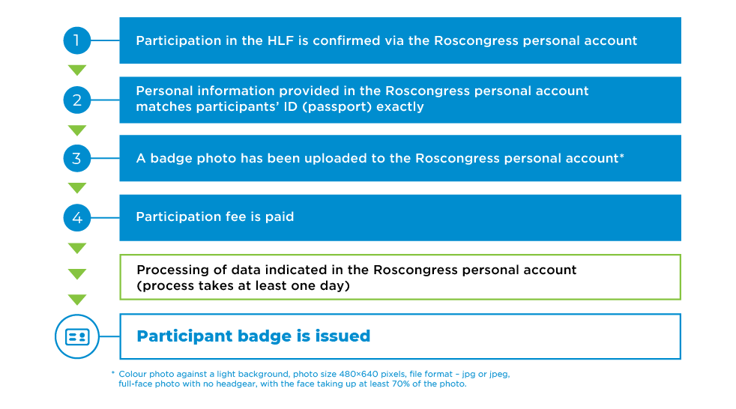
If information contained in the participant’s ID has changed in the time since a participation application was submitted, the participant’s Roscongress personal account must be updated accordingly. If changes need to be made to uneditable fields, please contact your personal manager at the Roscongress Foundation.
In order to expedite the procedure for issuing a badge, participants may upload a scan of their passport (pages containing photo and ID info) in the 'My Events – Healthy Life Forum – Event dashboard – Personal information' section of the Roscongress personal account.
Please ensure that scans are legible and contain all the information entered during registration, including passport number and serial number (if applicable), passport issuing authority,
date of issue, and photograph.
Format: jpg, jpeg, pdf, png.

How to find out if your badge is ready?
There are several ways to find out or be notified when a participant badge is ready:
- An email notification
- A notification in the participant’s Roscongress personal account
- A call to the Forum information canter +7 (495) 777 1006
- A call to a Roscongress Foundation specialist
If you have forgotten your login and password, you can use the login and password recovery function on the Roscongress personal account login page or contact us by email: weboffice@roscongress.org.

How to collect your badge?
COLLECTING A BADGE IN PERSON
Participant accreditation badges may be collected in person by presenting:
- The identity document that is listed in the Roscongress personal account
- Original of personal data consent form
COLLECTING A BADGE BY AUTHORIZED THIRD PARTY
If a participant’s badge is collected by a third party using a power of attorney, the authorized person must present the following:
- The authorized third party’s passport
- An original standard power of attorney
- A list of participants
- Copies of the passports of all participants to be accredited
- Originals of personal data consent forms
A power of attorney form and a personal data consent form can be downloaded from the ‘Badge collection’ section of the Forum website.
Before issuing a badge, an accreditation point attendant will make sure that the data specified in the Roscongress personal account corresponds to the ID document.
In the event of any discrepancies, it will not be possible to issue a badge the same day.

Where to collect your badge?
We kindly ask that you collect your accreditation badge in advance at the accreditation point in St. Petersburg.
Location | Dates | Operating hours
International Centre  for Business Cooperation  (6, Lafonskaya Ulitsa) | 20–22 March  23 March  24 March | 10:00–20:00  07:30–20:00  07:30–15:00

PARTICIPATION FEE PAYMENT
Participants can pay the participation fee at the financial services stands. The financial services stands also issue closing documents.
A 5.5% commission is charged when paying for participation and services at the financial services stands.
Participants can pay:
- in cash (in Russian roubles);
- by Visa, Mastercard, American Express, UnionPay, and MIR payment system cards issued by Russian banks;
- by UnionPay payment system cards issued by foreign banks.
Location | Dates | Operating hours
International Centre  for Business Cooperation  (6, Lafonskaya Ulitsa) | 22 March  23 March  24 March | 10:00–20:00  08:30–19:00  09:30–14:00

BUSINESS PROGRAMME
The Forum’s motto is ‘A Space for Cooperation in the Name of Health’.
VIEW DETAILED PROGRAMME
The business programme will cover a broad range of issues related to the development of healthcare:
- strategies to combat infectious and non-communicable diseases;
- the training of staff to meet the challenges of modern healthcare;
- the development of the primary branch of healthcare;
- the development of medical science;
- cooperation in drug security;
- the digital transformation of the industry;
- ensuring the quality and accessibility of medical care, and other themes.
The plenary session is titled ‘Priorities of the Healthcare Systems of CIS Member States’.
The plenary session and certain business programme events will feature simultaneous interpreting between Russian and English. Receivers for simultaneous interpreting are issued at the entrance to each hall hosting an event. In the Duma Hall, receivers for simultaneous interpreting are located on the tables.
An exhibition area is planned at the Forum venue, where innovative developments in the field of healthcare will be presented.

SERVICES FOR PARTICIPANTS

BROADCASTS OF FORUM EVENTS
A live broadcast of the plenary session and other business programme events, as well as the broadcast archive, will be available in the ‘Business programme’ section on the Forum website

Congress Attaché concierge service
The Congress Attaché concierge service is the official hotel and transport support partner of the Healthy Life Forum.
Congress Attaché concierge service stand (Tauride Palace, first floor, Kupolny Hall)
congressattache.com

ROSCONGRESS PHOTO BANK
The Roscongress Foundation provides photography for all events at the Healthy Life Forum. Photographs are published in the Roscongress photo bank in real time. Images can be displayed by event and date to facilitate browsing.
The photographs are available for viewing and free download in high resolution, and may be freely used, provided a reference to the Roscongress Foundation is included.
photo.roscongress.org

INFORMATION AND SERVICES POINT
Tauride Palace, first floor, Kupolny Hall
At information and services points, participants can obtain information on the Forum programme, available services, and directions around the Forum venue and other sites, as well as:
- copy and print documents;
- record information to electronic media;
- charge mobile devices;
- learn about things lost and found at the venue.

mobile device charging
You can charge your smartphone, tablet or power bank at the information and services point at the Forum venue (Tauride Palace, first floor, Kupolny Hall).

lost & found
You can find out about things lost and found at the Forum venue at the information and services point (Tauride Palace, first floor, Kupolny Hall).

Cloakroom
Tauride Palace, first floor

First aid
Ambulances will be stationed at the Forum venue for the duration of HLF.

ROSCONGRESS.ORG INFORMATION AND ANALYTICAL SYSTEM
The Roscongress Information and Analytical System is a unique Roscongress Foundation knowledge base.
The Roscongress IAS provides quick and easy access to all resources related to major business events in Russia that are organized by the Roscongress Foundation.
Features of the interactive knowledge base:
- Descriptions of 4,300+ sessions across more than 280 topics covering global and national development
- Talks, interviews, and insights from more than 15,000 speakers
- Research studies, articles, analytical digests, and expert reviews
Events participants and all visitors to the ROSCONGRESS.ORG website have a range of services at their disposal:
- «Блог Росконгресс» – интервью с известными деятелями культуры, науки и спорта, увлекательные рассказы о городах и регионах, в которых проходят мероприятия Фонда, а также материалы о стиле жизни деловых людей.
- Summary: analytical summaries of key discussions, including overviews of conclusions, objectives, and solutions.
- Analytical digests: a selection of analytical materials dedicated to important comprehensive studies on the business agenda of the forums.
- Video broadcasts of business programme events and the broadcast archive. Broadcasts are available in the ‘Programme’ section of the Forum website.
- Search video broadcasts: a feature enabling the user to search for information of interest within videos of events.
- The Roscongress Blog: interviews with famous people from the world of culture, sport and science, fascinating stories about the cities and regions in which congresses are held, and articles about the lifestyles of businesspeople.
Forum participants are able to use unique services and appreciate the advantages of the ROSCONGRESS.ORG Information and Analytical System in their mobile phones, tablets and computers.
roscongress.org

TRANSPORT

Forum shuttle buses
During the Forum, regular free shuttle buses for Forum participants and media representatives will run on the following routes:
Hotels → International Centre for Business Cooperation → Tauride Palace
23–24 March, 07:30–09:30
every 30 min.
Route 1.1 | Hotel Indigo / Radisson Sonya Hotel –  Tchaikovsky Grand Hotel → | → International Centre for Business Cooperation → Tauride Palace
Route 2.1 | Grand Hotel Emerald – Hotel Tavricheskiy →

Hotels → Tauride Palace
23 March, 09:30–16:00
24 March, 08:00–15:00
every 30 min.
Route 1.1 | Hotel Indigo / Radisson Sonya Hotel –  Tchaikovsky Grand Hotel → | → Tauride Palace
Route 2.1 | Grand Hotel Emerald – Hotel Tavricheskiy →

Tauride Palace → hotels
23 March, 12:45–18:00
24 March, 12:30–17:30
every 30 min.
Route 1.2 | Tauride Palace → | → Tchaikovsky Grand Hotel – Hotel Indigo / Radisson Sonya Hotel
Route 2.2 |  | → Hotel Tavricheskiy – Grand Hotel Emerald
The shuttle bus timetable may be subject to change. The latest timetable can be found in the ‘Shuttle buses’ section of the Forum website.

VEHICLE RENTALS
Participants can order a transfer from Pulkovo airport to the hotel and back, as well as rent a car for the entire duration of the Healthy Life Forum.
To rent a vehicle at special prices, you must send an application in any format to autobooking@congressattache.com. Car rental rates can be found in the ‘Vehicle rentals’ section of the Forum website.
If you have any questions, please contact the transport department manager:
+7 (812) 925 2129
autobooking@congressattache.com

DINING AT THE FORUM VENUE

coffee break area (free of charge)
Tauride Palace, Ekaterininsky Hall
Catering format: hot and cold drinks, snacks

Café (payment required)
Tauride Palace, west (right) side
Catering format: hot and cold drinks, snacks, sandwiches, desserts

GENERAL INFORMATION

EMERGENCY SERVICES
Rescue service (for mobile phone users): 112
Fire brigade: 101 (from mobile phones), 01
Police: 102 (from mobile phones), 02
Ambulance: 103 (from mobile phones), 03
St. Petersburg Tourist Information Bureau: +7 (812) 242 3906 (Mon to Sat, 10:00–19:00)

EMERGENCY PROCEDURES
The Forum venue is furnished with modern safety equipment, including video surveillance
and fire extinguishing systems.
In case of evacuation announcement, participants should:
- Keep calm and follow instructions of the Forum staff, the police and other persons responsible for maintaining public order and fire safety as well as the voice alarm instructions
- Not interfere with rescue personnel, police and transport operations
- Leave the venue according to the evacuation plans and follow the exit signs
- Give way to vehicles with sound and light signalling devices
We ask you to immediately report smoke, fire or any suspicious objects by dialling 112 on your mobile device and notify the Forum staff.

This information is valid as of 21 March 2023.
The latest information about the Forum can be found on the official website: forumhealth.ru.

